深 圳 大 学 实 验 报 告

课程编号： 2801000049

课程名称： 机器学习

实验项目名称： Machine Learning Task 1

学院： 电子与信息工程学院

专业： 电子信息工程

指导教师： 麦晓春

报告人：卫宏林 学号：2022300013 班级： 文华班

实验时间： 2024.3.16

实验报告提交时间： 2024.3.20

教务部制
1. Experimental Purposes and Requirements
(1) Be familiar with PCA and linear regression algorithms.
(2) Complete the programming tasks introduced in tutorials 1-5.
(3) Write a linear regression algorithm by yourself.- Use Boston House Dataset (506 samples and 13 feature variables), predict the value of prices of the house using the given features.- Split input data into training and testing sets (the testing set includes 10%ofthe samples).- The output of the algorithm should include the model learned from the whole training set, the average mean squared error (MSE) on training set via 10-fold cross validation.
For ridge regression model, determine the value of hyper-parameter via 10-fold cross validation.
(4) Write the experimental process and results into an experimental report. (strict content, abundant pictures and words).- See if there are any missing values in the data.- Exploratory data analysis (e.g., plot the distribution of the target variable, create a correlation matrix that measures the linear relationships between the variables and plot the correlation matrix, show the mean squared error (MSE) on testing set, plot a scatter plot between the original house price and predicted house prices).
(5) The source code should be submitted as an appendix (Just submitthe source code of the regression algorithm)
2. Experiment Contents and Process
2.1 Experiment 1
(1) Experimental Contents/Introduction
Write a linear regression algorithm.
Use Boston House Dataset (506 samples and 13 feature variables), predict the value of prices of the house using the given features.
(2) Methods
Multiple linear regression models:
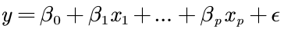
Asume
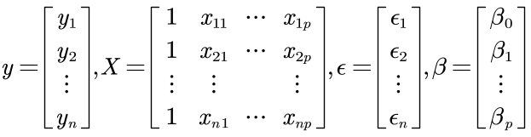
Minimize the function
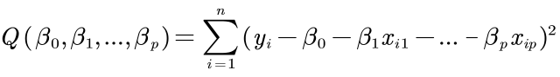
Finding the partial derivative for each parameter that needs to be estimated, we can get a series of equations as follows

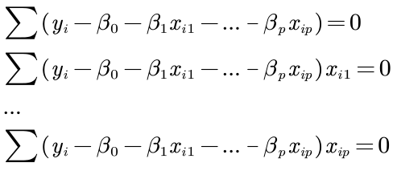
This is equivalent to the sum of the residuals of each element being 0
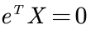
Because 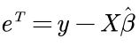
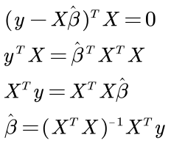
Define 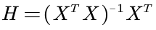 , so
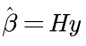
MSE
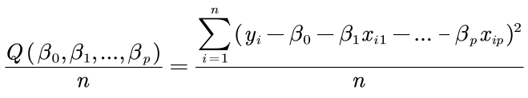

(3) Data Collection, Preprocessing and Analysis
Data: Boston House Dataset (506 samples and 13 feature variables)

See if there are any missing values in the data
Missing Values:
CRIM | ZN | INDUS | CHAS | NOX | RM | AGE | DIS | RAD | TAX | PIRATIO | B | LSTAT | MEDV
0 | 0 | 0 | 0 | 0 | 0 | 0 | 0 | 0 | 0 | 0 | 0 | 0 | 0

The result shows that without missing values in the data

- Exploratory data analysis (e.g., plot the distribution of the target variable

Create a correlation matrix that measures the linear relationships between the variables and plot the correlation matrix
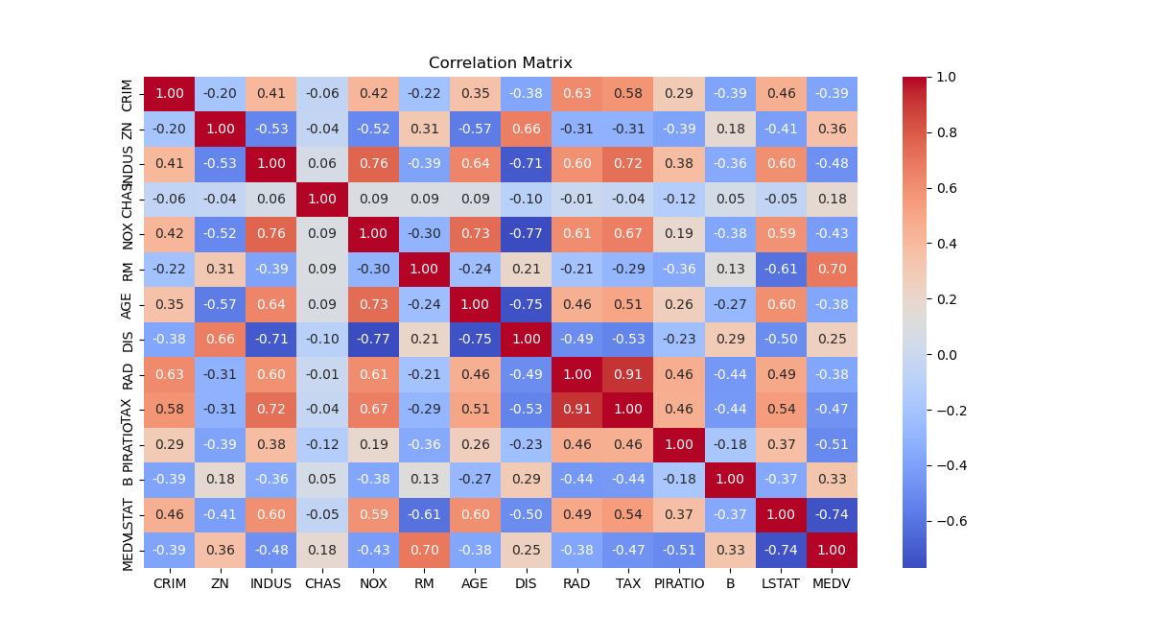
Figure 1 Correlation matrix between the variables

(4) Experimental Results and Analysis
1. Linear Regression Model:
- Model Coefficients:
Variable | Coefficient
CRIM | -0.120
ZN | 0.040
INDUS | 0.021
CHAS | 2.776
NOX | -18.585
RM | 3.756
AGE | 0.005
DIS | -1.471
RAD | 0.312
TAX | -0.012
PIRATIO | -0.948
B | 0.010
LSTAT | -0.550
- Average MSE on Training Set (10-fold Cross Validation): 24.907888998639386

- Linear Regression Model MSE on Testing Set: 14.995852876582926

2.2 Experiment 2
(1) Experimental Contents/Introduction
For ridge regression model, determine the value of hyper-parameter via 10-fold cross validation.
Use Boston House Dataset (506 samples and 13 feature variables), predict the value of prices of the house using the given features.
(2) Methods
On the basis of multiple linear regression, a penalty for coefficient values is added
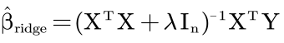
is the identity matrix, and the diagonal is all 1, similar to "mountain."
is the ridge coefficient, the value of which can be changed by changing the value of the diagonal of the identity matrix

The cost function becomes:
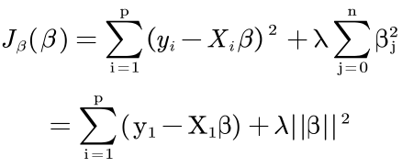
Ridge regression is an improved least squares estimation method, which obtains the regression coefficient at the cost of losing part of the information and reducing the accuracy by giving up the unbiased nature of the least squares method, which is a more practical and reliable regression method, and the fitting of the data with outliers is stronger than that of the least squares method.

(4) Experimental Results and Analysis
Ridge Regression Model:
- Best Hyper-parameter (alpha) selected: 0.1
- Average MSE on Training Set (10-fold Cross Validation): 24.909414528624904

Evaluation on Testing Set:
- Ridge Regression Model MSE on Testing Set: 14.933506462681148

3. Discussion and Conclusions
Multiple Linear Regression:

Multiple linear regression provides a transparent method to understand the relationships between multiple predictors and a target variable, as demonstrated in our analysis of Boston housing prices. By examining coefficients, we discerned the impact of each predictor on housing prices. However, its reliance on assumptions like multicollinearity and linearity can limit its applicability in complex datasets.

Ridge Regression:

Ridge regression, with its regularization parameter, addresses the limitations of multiple linear regression by stabilizing coefficients and mitigating multicollinearity. This improves model performance, especially in high-dimensional datasets. However, interpretability can be compromised due to regularization.

Conclusion:

Both multiple linear regression and ridge regression offer valuable insights into data relationships. The choice between them depends on the dataset's complexity and the need for model stability. Understanding these techniques equips analysts to make informed decisions across various fields, from economics to healthcare.

Appendix
- # Import necessary libraries
- import numpy as np
- import pandas as pd
- import matplotlib.pyplot as plt
- import seaborn as sns
- from sklearn.model_selection import train_test_split, cross_val_score, KFold
- from sklearn.linear_model import LinearRegression, Ridge
- from sklearn.metrics import mean_squared_error

- # Load Boston House Dataset from CSV
- data = pd.read_csv("boston.csv")

- # Check for missing values
- missing_values = data.isnull().sum()
- print("Missing Values:\n", missing_values)

- # Export missing values to Excel
- # missing_values.to_excel("missing_values.xlsx", header=["Missing Values"])

- # Exploratory Data Analysis
- # Distribution of the target variable (MEDV)
- plt.figure(figsize=(12, 6))
- sns.histplot(data['MEDV'], bins=30, kde=True)
- plt.title('Distribution of House Prices')
- plt.xlabel('Price (MEDV)')
- plt.ylabel('Frequency')
- plt.show()

- # Correlation matrix
- correlation_matrix = data.corr()
- plt.figure(figsize=(12, 8))
- sns.heatmap(correlation_matrix, annot=True, cmap='coolwarm', fmt='.2f')
- plt.title('Correlation Matrix')
- plt.show()

- # Split the data into features (X) and target variable (y)
- X = data.drop('MEDV', axis=1)
- y = data['MEDV']

- # Split the data into training and testing sets
- X_train, X_test, y_train, y_test = train_test_split(X, y, test_size=0.1, random_state=42)

- # Linear Regression Model
- lr_model = LinearRegression()
- lr_model.fit(X_train, y_train)

- # 10-fold cross-validation for Linear Regression
- cv_scores_lr = cross_val_score(lr_model, X_train, y_train, cv=10, scoring='neg_mean_squared_error')
- avg_mse_lr = -np.mean(cv_scores_lr)

- # Ridge Regression Model with hyper-parameter tuning
- alphas = [0.1, 1, 10, 100]
- best_alpha = None
- best_mse_ridge = float('inf')

- for alpha in alphas:
- ridge_model = Ridge(alpha=alpha)
- cv_scores_ridge = cross_val_score(ridge_model, X_train, y_train, cv=10, scoring='neg_mean_squared_error')
- avg_mse_ridge_cv = -np.mean(cv_scores_ridge)

- if avg_mse_ridge_cv < best_mse_ridge:
- best_mse_ridge = avg_mse_ridge_cv
- best_alpha = alpha

- # Final Ridge Regression Model with the best hyper-parameter
- ridge_model_final = Ridge(alpha=best_alpha)
- ridge_model_final.fit(X_train, y_train)

- # Evaluate models on the testing set
- y_pred_lr = lr_model.predict(X_test)
- mse_lr = mean_squared_error(y_test, y_pred_lr)

- y_pred_ridge = ridge_model_final.predict(X_test)
- mse_ridge = mean_squared_error(y_test, y_pred_ridge)

- # Scatter plot between the original and predicted house prices
- plt.figure(figsize=(12, 6))

- plt.subplot(1, 2, 1)
- plt.scatter(y_test, y_pred_lr)
- plt.title('Linear Regression: Original vs Predicted Prices')
- plt.xlabel('Original Prices')
- plt.ylabel('Predicted Prices')

- plt.subplot(1, 2, 2)
- plt.scatter(y_test, y_pred_ridge)
- plt.title('Ridge Regression: Original vs Predicted Prices')
- plt.xlabel('Original Prices')
- plt.ylabel('Predicted Prices')

- plt.tight_layout()
- plt.show()

- # Experimental Report
- print("\nExperimental Report:")
- print("1. Linear Regression Model:")
- # Combine coefficients and variable names into a DataFrame
- coefficients_df = pd.DataFrame({'Variable': X.columns, 'Coefficient': lr_model.coef_})

- # Export coefficients to Excel
- coefficients_df.to_excel("linear_regression_coefficients.xlsx", index=False)

- print(" - Average MSE on Training Set (10-fold Cross Validation):", avg_mse_lr)

- print("\n2. Ridge Regression Model:")
- print(" - Best Hyper-parameter (alpha) selected:", best_alpha)
- print(" - Average MSE on Training Set (10-fold Cross Validation):", best_mse_ridge)

- print("\n3. Evaluation on Testing Set:")
- print(" - Linear Regression Model MSE on Testing Set:", mse_lr)
- print(" - Ridge Regression Model MSE on Testing Set:", mse_ridge)

深圳大学学生实验报告用纸

指导教师批阅意见：

成绩评定：

指导教师签字：
年 月 日
备注：
注：1、报告内的项目或内容设置，可根据实际情况加以调整和补充。
2、教师批改学生实验报告时间应在学生提交实验报告时间后10日内。

